A000-Afr-Mali-Dogon-Crocodile Pirougue-Double Wedding Party-Bronze-Early 20th c

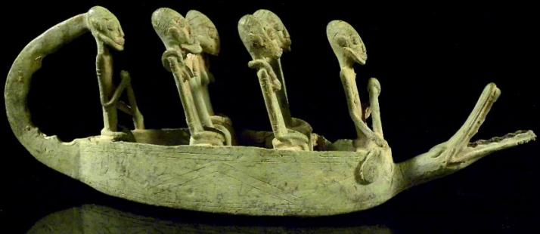

Fig. 1. Afr-Mali-Dogon-Crocodile Pirougue-Double Wedding Party-Bronze-Early 20th c

Case No.: 6

Accession No.

Formal Label: Afr-Mali-Dogon-Crocodile Pirougue-Double Wedding Party-Bronze-Early 20th c

Display Description:

The mythic Dogon mythic crocodile

Although the crocodile is the major predator of man in West Africa, as a totem animal of certain clans, it was considered as a benevolent protector of clan members from drowning, as in this bronze wedding pirogue with a crocodile totem on the prow protecting the dual wedded couples on their wedding journey on the Niger River.

Accession Number:

LC Classification:

Date or Time Horizon:

Geographical Area:

Map:

GPS coordinates:

Cultural Affiliation:

Medium: Bronze by Lost Wax Process

Dimensions: Height x Width: 4.3 x 12,2 in; 11 x 31 cm

Weight: 1.4 kg

Condition:

Provenance:

Discussion:

References: